Collaborative Institutional Training Initiative (CITI) Instructions

- Go to the CITI website at https://www.citiprogram.org.

- Login is necessary to access the modules required by TWU. Login with your CITI username and password or register as a New User.

- New Users complete Registration Steps 1 through 7 as they apply to you.
  - Select Texas Woman’s University from the drop-down list in Step 1.
  - Complete the other steps as they apply to you.
  - Save your username and password for future access to the site.

- Click the SUBMIT button when you have completed the registration steps.

- The next page is the TWU Member Information page. The fields marked with an asterisk must be completed. Click the SUBMIT button when you have completed this page.

- The next page lists all the curricula available to TWU Users. Question 4 is the Responsible Conduct of Research training. You can only select one course at this point, but you will be able to add others on the Main Menu page. Click the SUBMIT button when you have completed this page.
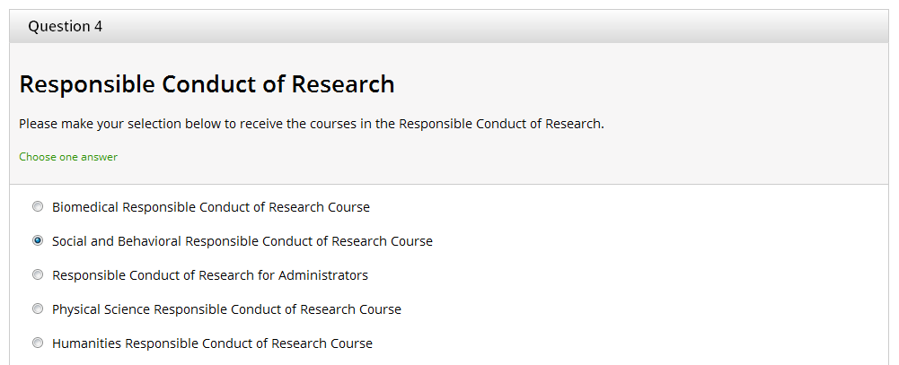

- The next page introduces the option to register with another institution. Select NO* to continue to the Main Menu.

- The next page is the Main Menu. This page lists the course for which you have enrolled and the status of that course. To select additional courses, click Add a course or update your learner groups for Texas Woman’s University.

- When you complete all required modules successfully, you may print your completion report through the “Print” link in the Learner's menu. Keep a copy of any certifications of completion for your records and to attach to Graduate School forms (e.g., Prospectus Cover Sheet, Graduate Faculty Application) as required.

*Please note that the option to affiliate with another institution is available from your Main Menu.

