

ANNUAL REPORT

FY 2024-2025

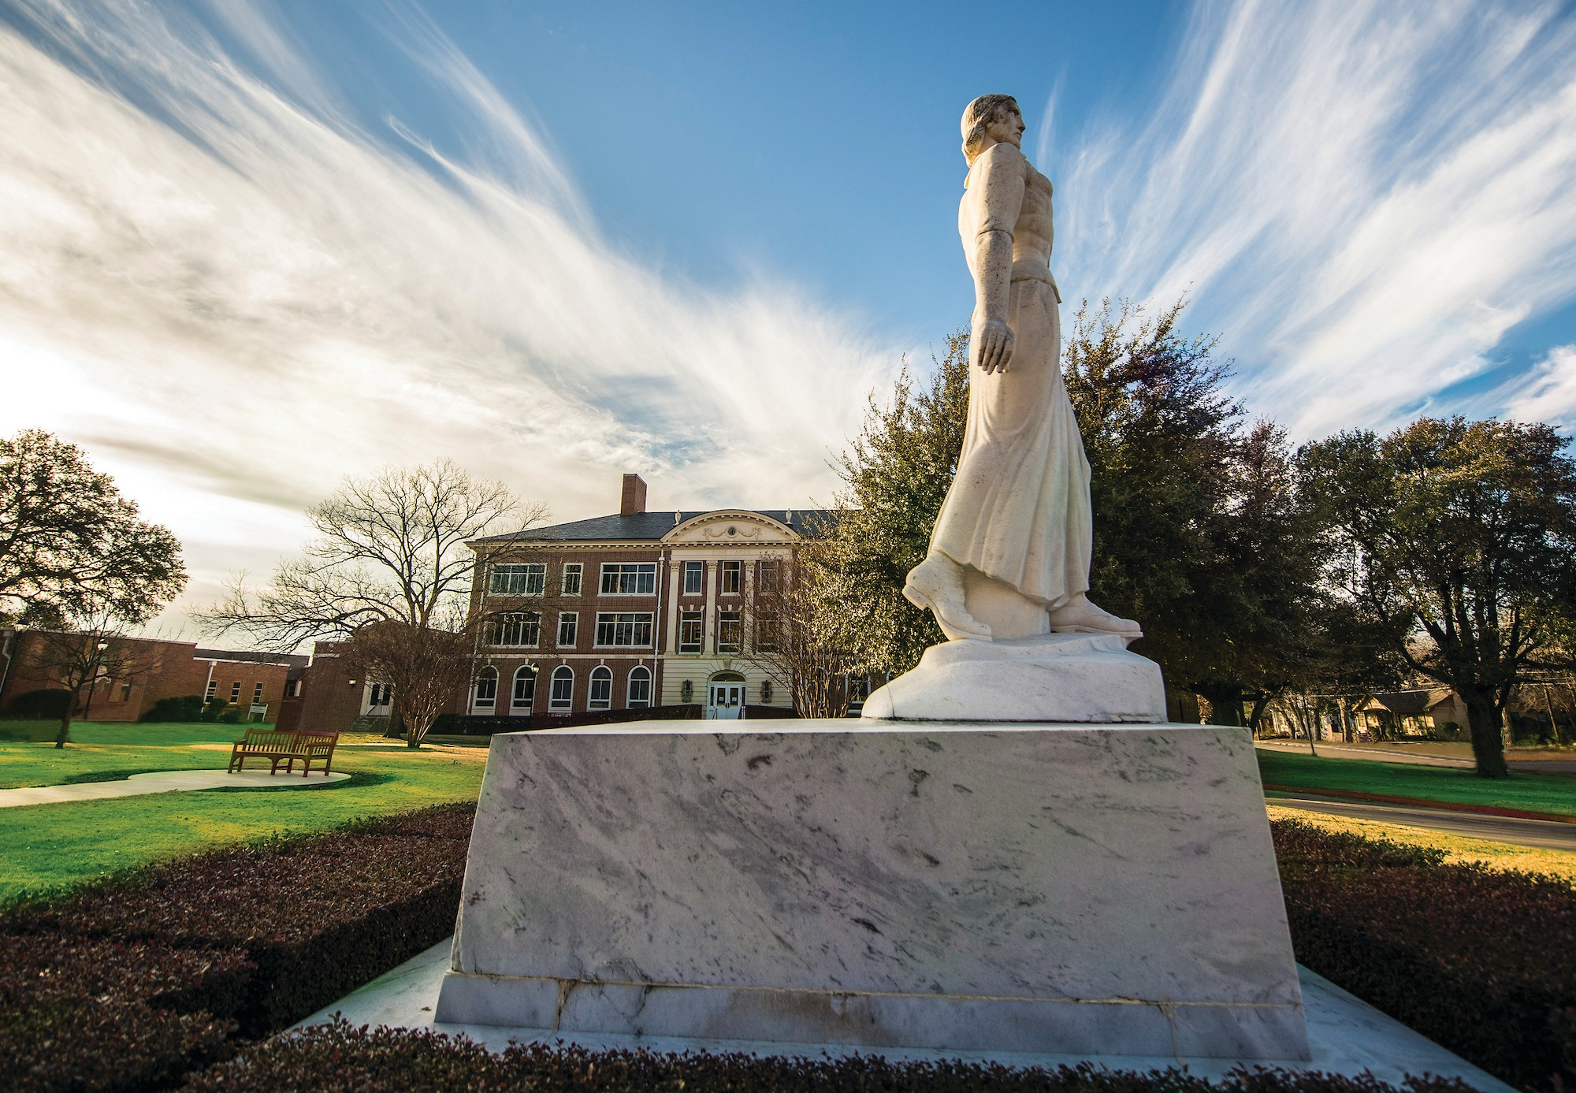

Table of Contents

Mission and Purpose 1

Highlights 1

Student Engagement By-the-Numbers 2

Student Research Grants Awarded 3

Student Research Presentation Grants Awarded 6

Compiled October 10, 2025
Contact: Dr. Diana Elrod delrod@twu.edu



Mission and Purpose
The mission of the Center for Student Research is to enhance the educational experience of students by providing opportunities for meaningful engagement in faculty-mentored research and creative activity opportunities. The purpose of the Center for Student Research is to promote an enhanced educational experience for students by providing opportunities for meaningful interaction between faculty and students through support, education, and programming in research and creative activities. The goals of CSR are to:
- provide opportunities for students to participate in all phases of research and creative activity, from design through dissemination;
- facilitate research partnerships between TWU students and faculty promoting faculty- mentored research opportunities for students;
- facilitate scholarly/creative partnerships between TWU students and faculty promoting faculty-mentored scholarly/creative opportunities for students;
- facilitate research collaboration between graduate and undergraduate students;
- enhance the students’ knowledge of all phases of research;
- promote a national presence for TWU students (i.e. National Council for Undergraduate Research - NCUR, Society for the Advancement of Chicanos and Natives Americans in Science - SACNAS); and
- ensure mutual benefit to both students and faculty members.

AY 2024 - 2025 Highlights
- Grants - Over $27,000 was awarded to both undergraduate and graduate students to support research and the presentation of research. The maximum for each award was $500 and 73 students (27 undergraduate and 46 graduates) were recipients. See individual award information section.
- Center for Student Research Workshop Series - Monthly presentations were provided virtually and topics included the following: When and How to Apply to Graduate School and the Role of Your Research, Your Personal Statement as Pat of your Graduate School Application and the Role of Your Research, Introducing the Center for Research Design & Analysis (CRDA), and Imposter Syndrome/Phenomenon and How it Can Impact your Research.
- Student Creative Arts and Research Symposium – For this symposium, over 270 abstracts were accepted for presentation and can be found in the 2025 Student Creative Arts & Research Symposium Program. The Chancellor’s Student Research Scholars were selected and received their awards. Students who accepted to the Symposium have been invited to place their research in the TWU Library Archives.

Student Engagement Summary  EVENT | # STUDENTS ENGAGED
Student Creative Arts and Research Symposium
Accepted Abstracts | 277
Poster Presentations | 179
Platform Presentations | 47
Virtual Presentations | 51
Total Presentations & Number of Students Engaged | 277*
* *As many abstracts had multiple authors, the actual number engaged is higher than the total number of abstracts.
CSR Student Research and Research Presentation/Publication Grant Awards
UG | 29
GS | 47
Total Engaged | 76
Workshops/Presentations/Individual Meetings
Total Engaged (UG & GS) | 150+
Total Engagements with UG & GS | 500+

2024-2025 Student Research Grants
Student(s)  Mentor  Department | Title of Research
Michelle Alexandre  Dr. Ann Malecha  College of Nursing | Trauma Providers' Perspectives on Intimate Partner Violence Screening and Identification
Elizabeth Bergman  Dr. Sharon Wang-Price  Physical Therapy - Dallas | Intra-Rater and Inter-Rater Reliability of Clinical Measurements for Hip Range of Motion and Hip Strength
Andrew Cain  Dr. Kelli Brizzolara  Physical Therapy | "Assessment of Pain Pressure Threshold and Core Endurance in Individuals with Non-Specific Low Back Pain as Compared to Healthy Controls: A Pilot Study"
Kelly Calhoun  Dr. Ronna Robbins  Nutrition & Food Sciences | Evaluating the Impact of Continuous Glucose Monitors on Dietary Choices and Metabolic Health in Non-Diabetic Older Adults
Cayla Clark  Dr. Rhett Rigby  School of Health Promotion & Kinesiology | Does Whole-Body Passive Heating, Aerobic Exercise, or a Combination of Heat and Aerobic Exercise Increase Heat Shock Protein Expression and Improve Motor and Non-Motor Symptoms of Parkinson’s Disease?
Charles Collins  Dr. Robin Conrad  Dance | An Embodied Journey
Chloe Coloura  Dr. Juliet Spencer  Biology | Impact of HCMV on the Immune System of Breast Cancer Patients
Cherisma Chowdary Ghanta  Dr. Mandana Pahlavani  Nutrition & Food Sciences | Optimized microencapsulation of red wine pomace, using coaxial Electrospinning
Shahnaz Gillani  Dr. Freysteinson Wayona  College of Nursing | What are the lived experiences and participants' perception, when viewing themselves in
Changyan Jin  Dr. Zhipeng Tao  Nutrition & Food Sciences | Identification of Protein Palmitoylation in Hepatocellular Carcinoma
Kelsi Lambright  Dr. Daniel Newmire  Kinesiology | The Effects of Menstrual Cycle Phases on IFG-1 and Myostatin
BreeAnna Lasha  Dr. Jennifer Woo  College of Nursing | BUMPS-CAPTURE: Black Women Utilizing Maternal Postpartum Doula Services Captured And Presented Through Unique Realistic Experiences
Ashley Latchford  Dr. Daniel Newmire  School of Health Promotion & Kinesiology | Physiological Changes in College Artistic Swimmers During a Competition Season: A Prospective Study
Byungjoo Lee  Dr. Shaochen Huang  School of Health Promotion & Kinesiology | Assessment of the shoulder joint orientation angle calculation methods
Hannah Leisure  Dr. Stina Soderling  Multicultural Women’s and Gender Studies | Oral Histories of Southern Lesbian Seniors
Winnie Lokuso  Dr. Christopher Brower  Biology | Investigating the Role of Cleaved Fragments in TDP43-Linked ALS and FTD
Violita McDonald  Dr. Angeles Nava  College of Nursing | The Lived Experiences of Texas Rural School Nurses Managing Respiratory Conditions
Carlos Mendez  Dr. Juliet Spencer  Biology | Impact of Human Cytomegalovirus on Cellular Lipid Composition
Madison Brooke Mills  Dr. Ronna Robbins  Nutrition & Food Sciences | EVALUATING THE IMPACT OF CONTINUOUS GLUCOSE MONITORING ON DIETARY CHOICES AND METABOLIC HEALTH IN NON-DIABETIC OLDER ADULTS
Kanji Mori  Dr. Shaochen Huang  School of Health Promotion & Kinesiology | The Efficacy of Solitary vs. Collaborative Practice in Learning Unimanual Coordination
Megan Morse  Dr. Sushmita Sinha  Biology | Signaling pathways for BATF3 up-regulation in human T cells
Angeles Munoz  Dr. Ale Babino  Literacy & Language | Re-Imagining Assessments for Emergent Bilinguals
Regina Newman  Dr. Helen Evert  Nutrition & Food Sciences | Dose-Dependent Effects of Vitamin A on Hair Follicle Stem Cell Markers
Abigail Penny  Dr. Yunxiang Li  Chemistry & Biochemistry | Examining the Energy Transmission Mediated by Two Loops in the y Subunit of Eschericia
Alondra Rangel  Dr. Zhipeng Tao  Nutrition & Food Sciences | Evaluating Traditional SDS-Page vs. Precast Gels in Protein Analysis
Angel Rittler  Dr. Heather Roberts  Occupational Therapy | Feasibility of a Somatosensory Enriched Pediatric Constraint Induced Movement Therapy Camp for Children with Hemiplegia Cerebral Palsy
Crystal Rodriguez  Dr. Laura Hanson  Biology | Does Cytomegalovirus Infection Increase Both or the Second Marker of Alzheimer's Disease?
Leslye Rodriguez  Dr. Zhipeng Tao  Nutrition & Food Sciences | The Efficient Amplification of Plasmid HMGB3
Jennifer Roos  Dr. Suh-Jen Lin  Physical Therapy | Quality Assessment of Garmin Vivoactive 5 Fitness Tracker
Sophia Santhosh  Dr. Jennifer Wilson  College of Nursing | Woven Traditions in a Digital Age: Revisiting Victorian Hairwork
Colton Sopher  Dr. Rhett Rigby  School of Health Promotion & Kinesiology | Acute Response to Aquatic Exercise in Youth with Cerebral Palsy
Samantha Sprigings  Dr. Christian Hart  Psychology and Philosophy | Validating Self-Report Lying Measures
Matthew Stankus  Dr. Mary Anderson  Chemistry & Biochemistry | Activity of Glutathione Synthetase and its Variants
Matthew Stankus  Dr. Mary Anderson  Chemistry & Biochemistry | MD Simulations to Explore Regulation of Human Glutathione Sythetase
Christine VanBuren  Dr. Helen Everts  Nutrition & Food Sciences | The Role of STRA6 in Retinol Procurement for Mitochondrial Oxidative Phosphorylation
Zoe Venglarik  Dr. Danhui Wang  Nutrition & Food Sciences | Evaluating the Viability of Probiotics in Commercial Yogurt Products
Danielle Vines  Dr. Aaron Norton  Marriage and Family Therapy | Between Inner Desire and Outer Expression: A Phenomenological Study of Sexual Consent in Long-Term Couples.

2024-2025 Student Research Presentation Grants

Students  Mentor  Department |  | Title of Research Presentation or Publication
Dinvela Adam  Mr. Justin Ashley  Theatre |  | Irene Ryan Acting Scholarship Auditions at KCACTF
Hunter Alvis  Dr. Rhett Rigby  School of Health Promotion & Kinesiology |  | Blood Flow Restriction During in Exercise in Spaceflight
Hunter Alvis  Dr. Rhett Rigby  School of Health Promotion & Kinesiology |  | Mitigation of Muscle Atrophy During Long-Duration Spaceflight
Hafsa Baba  Dr. Sharon Wang-Price  Physical Therapy - Dallas |  | Best Manual Physical Therapy Management Practices for Chronic Neck Pain - A Scoping Review
Amit Basnet  Dr. Dayna Averitt  Biology |  | Estrogen Modulates Inflammatory Mediator Release from Macrophages
Anitta Biju  Dr. Alannah Shelby Rivers  Psychology and Philosophy |  | Relationship self-efficacy in close relationships
Makiyah Brittmon  Dr. Rhett Rigby  School of Health Promotion & Kinesiology |  | Blood Flow Restriction During in Exercise in Spaceflight
Erika Brown  Dr. James Williams  Social Sciences and Historical Studies |  | From Podcasting to Praxis: Exploration of Inequality in Black America via the Broke-ish® Podcast
Hana Choi  Dr. Mijin Kim  Psychology and Philosophy |  | Poster: Migratory grief and Depression: Emotion Regulation Among Korean Immigrants  Symposium: Cultural Identity as Strength: Collective Self-Esteem and Well-being in Korean American Communities  Poster: Healthcare Trust and Discrimination: Impacts on Asian American Patents' Wellbeing
Trinity Douglas  Dr. Adam Jones  School of Human Sciences, Counseling & Development |  | Evaluating and Developing Facilitative Systemic Intervention Skills (Workshop)  Enhancing Therapeutic Responses: The Role of Deliberate Practice in Multicultural Family Therapy (Poster)
Cassidy Duan  Dr. Ziaofen Du  Nutrition & Food Sciences |  | Key role of texture in fresh-cut vegtables and characterization of texture-related parameters in cucumber
Cherishma Chowdary Ghanta  Dr. Mandana Pahlavani  Nutrition & Food Sciences |  | Optimized Microencapsulation of Red Wine Pomace, Using Coaxial Electrospinning
Christine Gilfrich  Dr. Ana Louise Keating  Language, Culture, and Gender Studies |  | Autohistoria-teoria Archival Research at the Benson Latin American Studies Collection
Kate Hilton  Dr. Adam Jones  School of Human Sciences |  | Relationships Between Observer - and Self-Rated Systematic Therapist Skills
Martha Hinojosa  Dr. Rhett Rigby  Health Promotion & Kinesiology |  | Mitigation of Muscle Atrophy During Long-Duration Spaceflight
Bitali Islam  Dr. Dayna Averitt  Biology |  | Transcriptome Analysis of Trigeminal Ganglia Following Sub-Chronic Stress Exposure in a Rat Model of Orofacial Inflammatory Pain
Anaya Kashikar  Dr. Rhett Rigby  School of Health Promotion & Kinesiology |  | Mitigation of Muscle Atrophy During Long-Duration Spaceflight
Kelsi Lambright  Dr. Daniel Newmire  Kinesiology |  | The Effects of Menstrual Cycle Phase on IGF-1 and Myostatin After an Acute Bout of Anaerobic Exercise
Ian LaRue  Dr. Juliet Spencer  Biology |  | Lack of Cytopathic Effects In Breast Cancer Cells Infected With Human Cytomegalovirus
Clay Martin  Dr. Rhett Rigby  School of Health Promotion & Kinesiology |  | Mitigation of Muscle Atrophy During Long-Duration Spaceflight
Michelle Nishida  Dr. Jyutika Mehta  Communication Sciences and Oral Health |  | Effects of Combining tDCS and Facial Emotion Recognition Therapy in Young Adults with Autism
Marina Obradovic  Dr. Nasrin Mirsaleh Kohan  Chemistry and Biochemistry |  | Characterizing Cisplatin-DNA Interactions Using HPLC-MS and Guanosine Monophosphate Models
Temiloluwa (Peace) Olaoluwa  Dr. Dayna Averitt  Biology |  | Euphorbia Bicolor Phytochemicals Reduce Neural and Inflammatory Markers of Burn Pain in a Rat Model of Full Thickness Thermal Injury
Laila Pacheco  Dr. Hui-Ting Goh  School of Health Promotion & Kinesiology |  | A Scoping Review of the Association between Post-Stroke Fatigue and Neuroimaging Markers
Serina Patel  Dr. Christopher Brower  Biology |  | IlluminATE1
Matthew Pearson  Dr. Rhett Rigby  School of Health Promotion & Kinesiology | Mitigation of Muscle Atrophy During Long-Duration Spaceflight
Michael Vincent Preciado  Dr. Jennifer Wilson  College of Nursing | Leveraging Undergraduate Nursing Research Collaboration to Evaluate Community Education and Communication Outcomes
Bahia Ramirez  Dr. Debra Mollen  Counseling Psychology PhD | Conservatism and Anti-Blackness: Applying Research to Practice and Advocacy
Madeline Ratoza  Dr. Rupal Patel  Physical Therapy - Houston | "1: A Socio-Demographic Exploration of the Population to PT/OT Provider Ratio across the State of Texas  2: Utility of Spatial Analysis to Model Rehabilitation Provider Shortage Areas: Verifying Datasets of Clinic Locations"
Erin Rocha  Dr. Rhett Rigby  School of Health Promotion & Kinesiology | Blood Flow Restriction During in Exercise in Spaceflight
Josey Salazar  Dr. Rhett Rigby  School of Health Promotion & Kinesiology | Blood Flow Restriction During in Exercise in Spaceflight
Hannah Schnettler  Dr. Rhett Rigby  School of Health Promotion & Kinesiology | Blood Flow Restriction During in Exercise in Spaceflight
Madeline Schock  Dr. Adam Jones  School of Human Sciences, Marriage and Family Therapy | Therapist Self-Efficacy & Skills
Karolyn Skoby  Dr. Rhett Rigby  School of Health Promotion & Kinesiology  Samantha Sprigings  Dr. Christian Hart  Psychology and Philosophy  Matthew Stankus  Dr. Mary Anderson  Chemistry & Biochemistry  Priya Thomas  Dr. Hui-Ting Goh  Physical Therapy  Mengdi Wang  Dr. Hui-Ting Goh  Physical Therapy | Blood Flow Restriction During in Exercise in Spaceflight  Development of the Face-Saving Lies Scale  Simulations to Explore Regulation of Human Glutathione Synthetase  Impact of post-stroke fatigue on perceived effort during reaching: a replication study  Neurophysiological Changes Associated with gait Recovery in Incomplete Spinal Cord Injury: A Preliminary Analysis of TMS Measures

